Coronavirus disease 2019 (COVID-19)
Situation Report – 78

Data as receiv ed by WHO from national authorities by 10:00 CET 7 April 2020

HIGHLIGHTS
- One new country/territory/area reported cases of COVID-19 in the past 24 hours: São Tomé and Príncipe.

- Today, 7 April, marks World Health Day and this year WHO pays tribute to the incredible contribution of all health workers, especially nurses and midwives. Nurses are the largest component of the health workforce and play a fundamental role in combatting COVID-19 and achieving Universal Health Coverage and the Sustainable Development Goals. WHO has published the first-ever report on the state of the world’s nursing workforce, available here. It renews calls on governments to invest in nurses.

- WHO, Lady Gaga and Global Citizen have announced a concert to air on Saturday, 18 April 2020 titled 'One World: Together at home'. This globally televised and streamed special will highlight unity among all people affected by COVID-19, celebrate the brave healthcare workers doing life-saving work, and raise funds for the response. More information is available here.

- WHO Director-General Dr Tedros, in a press conference held yesterday, reiterated concerns regarding the shortage of medical masks and other PPE and reminded people that masks should be used as part of a comprehensive package of interventions. WHO has released guidance on the use of masks in communities, during home care, and in healthcare settings that can be found here; further advice for the public can be found here.

- WHO is improving supply networks and logistics in clinical environments, and
sending equipment and testing kits worldwide. See ‘Subject in Focus’ below.
SITUATION IN NUMBERS
total (new ) cases in last 24 hours

Globally
1 279 722 confirmed (68 766)
72 614 deaths (5020)

Western Pacific Region
113 641 confirmed (1119)
3892 deaths (31)
European Region
686 338 confirmed (30 999)
52 809 deaths (3330)

South-East Asia Region
9132 confirmed (304)
362 deaths (18)

Eastern Mediterranean Region
78 565 confirmed (4218)
4149 deaths (173)

Region of the Americas
384 242 confirmed (31 650)
11 097 deaths (1417)

African Region
7092 confirmed (476)
294 deaths (51)

WHO RISK ASSESSMENT
Global Level Very High

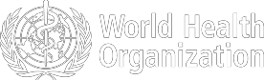
Figure 1. Countries, territories or areas with reported confirmed cases of COVID-19, 7 April 2020

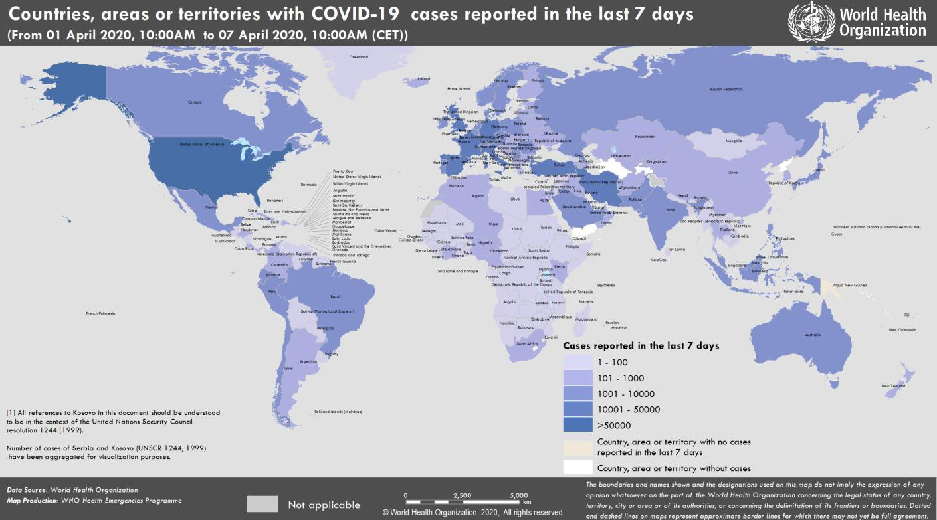

SUBJECT IN FOCUS: Supporting countries with COVID-19 supplies and logistical needs

Improving supply networks

Significant efforts are underway to improve access to items essential for the COVID -19 emergency response. Through the continued efforts of WHO and the Pandemic Supply Chain Network (PSCN), the personal protective equipment (PPE) manufacturing market is beginning to open, however demand continues to outstrip available supply.

The Operations Support and Logistics (OSL) unit at WHO is working to convene meetings with key stakeholders including oxygen, ventilator and concentrator manufacturers and producers of associated ancillary equipment. In addition to securing the appropriate equipment for those countries at most risk or most vulnerable, WHO and the PSCN is working with the World Bank and other UN agencies to ensure that the infrastructure, technical guidance and other operational guidance is available.

Through collaboration with the Clinton Health Access Initiative (CHAI), OSL’s COVID -19 Essential Supplies Forecasting Tool has been finalized. Output from the model is being shared with partners and is assisting both procurement agencies and suppliers in understanding national requirements of key supplies.

Sending personal protective equipment and testing kits

Since the beginning of the outbreak, OSL has shipped more than 900 000 surgical masks, 62 000 N95 masks, 1 million gloves, 115 000 gowns, 17 000 goggles and 34 000 face shields to 133 countries. OSL has also shipped COVID-19 testing kits to 126 countries.

Strengthening health logistics in clinical environments

OSL has also launched and supported the COVID-19 Health Logistics Project, establishing direct technical support to hospitals to re-design their facilities into infectious disease treatment units. This support has included improving patient and healthcare worker flow, promoting rational use of PPE, and minimizing nosocomial transmission.

To achieve these aims, OSL has established the Health Logistics Technical Network (HLTN). The network is composed of recognized universities, humanitarian institutions and international NGOs focused on technical interventions. A WHO-based helpdesk serves as a centralized resource to answer technical questions, verify and provide inputs on COVID-19 facility layouts, troubleshoot problems, and facilitate solutions to problems while supporting experts in the field. Helpdesk support has been successfully provided in Australia for the Canberra Hospital Campus SARI layout, and additional support has been requested from Italy and France.
SURVEILLANCE

Table 1. Countries, territories or areas with reported laboratory-confirmed COVID-19 cases and deaths. Data as of 7 April 2020*
Reporting Country/ Territory/Area† | Total confirmed  ‡ cases |  | Total confirmed new cases | Total deaths | Total new deaths | Transmission classification§ | Days since last reported case
Western Pacific Region
China |  | 83071 | 66 | 3340 | 0 | Local transmission | 0
Republic of Korea |  | 10331 | 47 | 192 | 6 | Local transmission | 0
Australia |  | 5844 | 100 | 42 | 6 | Local transmission | 0
Japan |  | 3906 | 252 | 80 | 7 | Local transmission | 0
Malaysia |  | 3793 | 131 | 62 | 1 | Local transmission | 0
Philippines |  | 3660 | 414 | 163 | 11 | Local transmission | 0
Singapore |  | 1375 | 66 | 6 | 0 | Local transmission | 0
New Zealand |  | 943 | 32 | 1 | 0 | Local transmission | 0
Viet Nam |  | 245 | 4 | 0 | 0 | Local transmission | 0
Brunei Darussalam |  | 135 | 0 | 1 | 0 | Local transmission | 2
Cambodia |  | 115 | 1 | 0 | 0 | Local transmission | 0
Mongolia |  | 15 | 1 | 0 | 0 | Imported cases only | 0
Fiji |  | 14 | 2 | 0 | 0 | Local transmission | 0
Lao People's  Democratic Republic |  | 12 | 1 | 0 | 0 | Local transmission | 0
Papua New Guinea |  | 1 | 0 | 0 | 0 | Imported cases only | 17
Territories**
Guam |  | 113 | 1 | 4 | 0 | Local transmission | 0
French Polynesia |  | 42 | 1 | 0 | 0 | Local transmission | 0
New Caledonia |  | 18 | 0 | 0 | 0 | Local transmission | 4
Northern Mariana  Islands (Commonwealth of the) |  | 8 | 0 | 1 | 0 | Local transmission | 4
European Region
Spain |  | 135032 | 4273 | 13055 | 637 | Local transmission | 0
Italy |  | 132547 | 3599 | 16525 | 636 | Local transmission | 0
Germany |  | 99225 | 3834 | 1607 | 173 | Local transmission | 0
France |  | 73488 | 3881 | 8896 | 832 | Local transmission | 0
The United Kingdom |  | 51612 | 3802 | 5373 | 439 | Local transmission | 0
Turkey |  | 30217 | 3148 | 649 | 75 | Local transmission | 0
Switzerland |  | 21574 | 509 | 715 | 0 | Local transmission | 0
Belgium |  | 20814 | 1123 | 1632 | 185 | Local transmission | 0
Netherlands |  | 18803 | 952 | 1867 | 101 | Local transmission | 0
Austria |  | 12297 | 314 | 220 | 16 | Local transmission | 0
Portugal |  | 11730 | 452 | 311 | 16 | Local transmission | 0
Israel |  | 8611 | 593 | 52 | 6 | Local transmission | 0
Sweden |  | 7206 | 376 | 477 | 76 | Local transmission | 0
Russian Federation |  | 6343 | 954 | 47 | 2 | Local transmission | 0
Norway |  | 5755 | 115 | 59 | 1 | Local transmission | 0
Ireland |  | 5364 | 253 | 174 | 16 | Local transmission | 0

Czechia | 4822 | 235 | 78 | 11 | Local transmission | 0
Denmark | 4681 | 312 | 187 | 8 | Local transmission | 0
Poland | 4413 | 311 | 107 | 13 | Local transmission | 0
Romania | 4057 | 193 | 157 | 9 | Local transmission | 0
Luxembourg | 2843 | 39 | 41 | 5 | Local transmission | 0
Serbia | 2200 | 292 | 58 | 7 | Local transmission | 0
Finland | 2176 | 249 | 28 | 0 | Local transmission | 0
Greece | 1755 | 20 | 79 | 6 | Local transmission | 0
Iceland | 1562 | 76 | 6 | 2 | Local transmission | 0
Ukraine | 1462 | 143 | 45 | 7 | Local transmission | 0
Croatia | 1222 | 40 | 16 | 1 | Local transmission | 0
Estonia | 1108 | 11 | 19 | 4 | Local transmission | 0
Slovenia | 1021 | 24 | 30 | 2 | Local transmission | 0
Republic of Moldova | 965 | 101 | 19 | 4 | Local transmission | 0
Lithuania | 843 | 32 | 14 | 1 | Local transmission | 0
Armenia | 833 | 87 | 8 | 1 | Local transmission | 0
Hungary | 817 | 73 | 47 | 9 | Local transmission | 0
Belarus | 700 | 138 | 13 | 5 | Local transmission | 0
Bosnia and  Herzegovina | 695 | 33 | 28 | 7 | Local transmission | 0
Kazakhstan | 670 | 66 | 6 | 1 | Local transmission | 0
Azerbaijan | 641 | 57 | 7 | 2 | Local transmission | 0
North Macedonia | 570 | 15 | 21 | 3 | Local transmission | 0
Bulgaria | 549 | 18 | 22 | 2 | Local transmission | 0
Latvia | 542 | 9 | 1 | 0 | Local transmission | 0
Andorra | 540 | 17 | 21 | 4 | Local transmission | 0
Slovakia | 534 | 49 | 2 | 2 | Local transmission | 0
Uzbekistan | 472 | 82 | 2 | 0 | Local transmission | 0
Cyprus | 465 | 19 | 14 | 0 | Local transmission | 0
Albania | 377 | 0 | 22 | 1 | Local transmission | 1
San Marino | 277 | 11 | 32 | 0 | Local transmission | 0
Malta | 241 | 7 | 0 | 0 | Local transmission | 0
Kyrgyzstan | 228 | 12 | 4 | 0 | Local transmission | 0
Montenegro | 223 | 20 | 2 | 0 | Local transmission | 0
Georgia | 195 | 7 | 2 | 0 | Local transmission | 0
Liechtenstein | 78 | 0 | 1 | 0 | Under investigation | 1
Monaco | 40 | 3 | 0 | 0 | Local transmission | 0
Holy See | 7 | 0 | 0 | 0 | Under investigation | 4
Territories**
Faroe Islands | 181 | 0 | 0 | 0 | Local transmission | 2
Kosovo[1] | 165 | 20 | 3 | 2 | Local transmission | 0
Jersey | 155 | 0 | 3 | 0 | Local transmission | 1
Guernsey | 154 | 0 | 3 | 0 | Local transmission | 1
Isle of Man | 127 | 0 | 1 | 0 | Local transmission | 1
Gibraltar | 103 | 0 | 1 | 0 | Local transmission | 1
Greenland | 11 | 0 | 0 | 0 | Under investigation | 1
South-EastAsia Region
India | 4067 | 0 | 109 | 0 | Local transmission | 1
Indonesia | 2491 | 218 | 209 | 11 | Local transmission | 0

Thailand | 2220 | 51 | 26 | 3 | Local transmission | 0
Sri Lanka | 176 | 0 | 5 | 0 | Local transmission | 1
Bangladesh | 123 | 35 | 12 | 4 | Local transmission | 0
Myanmar | 21 | 0 | 1 | 0 | Local transmission | 1
Maldives | 19 | 0 | 0 | 0 | Local transmission | 4
Nepal | 9 | 0 | 0 | 0 | Local transmission | 2
Bhutan | 5 | 0 | 0 | 0 | Imported cases only | 4
Timor-Leste | 1 | 0 | 0 | 0 | Imported cases only | 17
Eastern Mediterranean Region
Iran (Islamic Republic  of) | 60500 | 2274 | 3739 | 136 | Local transmission | 0
Pakistan | 3864 | 587 | 54 | 4 | Local transmission | 0
Saudi Arabia | 2752 | 289 | 38 | 4 | Local transmission | 0
United Arab Emirates | 2076 | 277 | 11 | 1 | Local transmission | 0
Qatar | 1832 | 228 | 4 | 0 | Local transmission | 0
Egypt | 1322 | 149 | 85 | 7 | Local transmission | 0
Morocco | 1141 | 28 | 83 | 12 | Local transmission | 0
Iraq | 1031 | 70 | 64 | 3 | Local transmission | 0
Bahrain | 756 | 56 | 4 | 0 | Local transmission | 0
Kuwait | 665 | 109 | 1 | 0 | Local transmission | 0
Tunisia | 596 | 22 | 22 | 0 | Local transmission | 0
Lebanon | 541 | 14 | 19 | 1 | Local transmission | 0
Oman | 371 | 40 | 2 | 0 | Local transmission | 0
Afghanistan | 367 | 30 | 11 | 4 | Local transmission | 0
Jordan | 349 | 4 | 6 | 1 | Local transmission | 0
Djibouti | 90 | 31 | 0 | 0 | Local transmission | 0
Syrian Arab Republic | 19 | 0 | 2 | 0 | Local transmission | 1
Libya | 18 | 0 | 1 | 0 | Local transmission | 1
Sudan | 14 | 2 | 2 | 0 | Local transmission | 0
Somalia | 7 | 0 | 0 | 0 | Local transmission | 3
Territories**
occupied Palestinian territory | 254 | 8 | 1 | 0 | Local transmission | 0
Region of the Americas
United States of  America | 333811 | 26493 | 9559 | 1201 | Local transmission | 0
Canada | 15806 | 1902 | 293 | 62 | Local transmission | 0
Brazil | 11130 | 852 | 486 | 54 | Local transmission | 0
Chile | 4815 | 344 | 37 | 3 | Local transmission | 0
Ecuador | 3747 | 282 | 191 | 19 | Local transmission | 0
Peru | 2281 | 535 | 83 | 10 | Local transmission | 0
Mexico | 2143 | 253 | 94 | 15 | Local transmission | 0
Panama | 1988 | 187 | 54 | 8 | Local transmission | 0
Dominican Republic | 1828 | 340 | 86 | 18 | Local transmission | 0
Argentina | 1554 | 103 | 46 | 2 | Local transmission | 0
Colombia | 1485 | 79 | 35 | 3 | Local transmission | 0
Costa Rica | 454 | 19 | 2 | 0 | Local transmission | 0
Uruguay | 406 | 6 | 6 | 1 | Local transmission | 0
Cuba | 350 | 30 | 9 | 1 | Local transmission | 0
Honduras | 298 | 30 | 22 | 0 | Local transmission | 0

Bolivia (Plurinational State of) | 183 | 26 | 11 | 1 | Local transmission | 0
Venezuela (Bolivarian Republic of) | 159 | 15 | 3 | 0 | Local transmission | 0
Paraguay | 113 | 9 | 5 | 2 | Local transmission | 0
Trinidad and Tobago | 105 | 2 | 8 | 2 | Local transmission | 0
Guatemala | 70 | 9 | 3 | 1 | Local transmission | 0
El Salvador | 69 | 7 | 3 | 0 | Local transmission | 0
Jamaica | 58 | 3 | 3 | 0 | Local transmission | 0
Barbados | 56 | 5 | 1 | 1 | Local transmission | 0
Bahamas | 29 | 1 | 5 | 1 | Local transmission | 0
Guyana | 29 | 5 | 4 | 0 | Local transmission | 0
Haiti | 24 | 3 | 1 | 1 | Imported cases only | 0
Antigua and Barbuda | 15 | 8 | 0 | 0 | Local transmission | 0
Dominica | 14 | 3 | 0 | 0 | Local transmission | 0
Saint Lucia | 14 | 0 | 0 | 0 | Local transmission | 1
Grenada | 12 | 0 | 0 | 0 | Local transmission | 2
Saint Kitts and Nevis | 10 | 1 | 0 | 0 | Imported cases only | 0
Suriname | 10 | 0 | 1 | 1 | Local transmission | 3
Belize | 7 | 2 | 1 | 1 | Local transmission | 0
Saint Vincent and the  Grenadines | 7 | 4 | 0 | 0 | Imported cases only | 0
Nicaragua | 6 | 1 | 1 | 0 | Imported cases only | 0
Territories**
Puerto Rico | 513 | 61 | 21 | 3 | Local transmission | 0
Martinique | 149 | 4 | 4 | 1 | Local transmission | 0
Guadeloupe | 135 | 1 | 7 | 0 | Local transmission | 0
French Guiana | 68 | 2 | 0 | 0 | Local transmission | 0
Aruba | 64 | 0 | 0 | 0 | Local transmission | 2
United States Virgin Islands | 43 | 1 | 1 | 1 | Local transmission | 0
Cayman Islands | 39 | 4 | 1 | 0 | Local transmission | 0
Bermuda | 37 | 0 | 0 | 0 | Local transmission | 1
Sint Maarten | 37 | 14 | 6 | 4 | Imported cases only | 0
Saint Martin | 31 | 2 | 2 | 0 | Under investigation | 0
Curaçao | 13 | 2 | 1 | 0 | Imported cases only | 0
Montserrat | 6 | 0 | 0 | 0 | Imported cases only | 2
Saint Barthélemy | 6 | 0 | 0 | 0 | Under investigation | 7
Turks and Caicos Islands | 5 | 0 | 1 | 0 | Local transmission | 7
Anguilla | 3 | 0 | 0 | 0 | Local transmission | 3
British Virgin Islands | 3 | 0 | 0 | 0 | Imported cases only | 6
Bonaire, Sint Eustatius and Saba | 2 | 0 | 0 | 0 | Imported cases only | 3
Falkland Islands (Malvinas) | 2 | 0 | 0 | 0 | Under investigation | 1
African Region
South Africa | 1686 | 31 | 12 | 1 | Local transmission | 0
Algeria | 1423 | 172 | 173 | 43 | Local transmission | 0
Cameroon | 555 | 0 | 9 | 0 | Local transmission | 2

Burkina Faso | 345 | 43 | 17 | 2 | Local transmission | 0
Côte d’Ivoire | 323 | 78 | 3 | 1 | Local transmission | 0
Mauritius | 244 | 17 | 7 | 0 | Local transmission | 0
Nigeria | 232 | 24 | 5 | 1 | Local transmission | 0
Senegal | 226 | 4 | 2 | 0 | Local transmission | 0
Ghana | 214 | 9 | 5 | 0 | Local transmission | 0
Niger | 184 | 40 | 10 | 2 | Local transmission | 0
Democratic Republic  of the Congo | 161 | 0 | 18 | 0 | Local transmission | 1
Kenya | 142 | 0 | 4 | 0 | Local transmission | 1
Guinea | 111 | 0 | 0 | 0 | Local transmission | 2
Rwanda | 104 | 2 | 0 | 0 | Local transmission | 0
Madagascar | 77 | 0 | 0 | 0 | Local transmission | 1
Uganda | 52 | 4 | 0 | 0 | Local transmission | 0
Congo | 45 | 0 | 5 | 0 | Local transmission | 2
Togo | 44 | 0 | 3 | 0 | Local transmission | 1
Ethiopia | 43 | 0 | 1 | 0 | Local transmission | 1
Mali | 39 | 0 | 4 | 0 | Local transmission | 2
Zambia | 39 | 0 | 1 | 0 | Local transmission | 4
Guinea-Bissau | 33 | 15 | 0 | 0 | Imported cases only | 0
Eritrea | 29 | 0 | 0 | 0 | Local transmission | 1
United Republic of  Tanzania | 24 | 2 | 1 | 0 | Local transmission | 0
Benin | 23 | 1 | 1 | 1 | Local transmission | 0
Gabon | 21 | 0 | 1 | 0 | Imported cases only | 3
Angola | 16 | 2 | 2 | 0 | Imported cases only | 0
Equatorial Guinea | 16 | 0 | 0 | 0 | Local transmission | 2
Namibia | 16 | 0 | 0 | 0 | Local transmission | 1
Liberia | 14 | 1 | 3 | 0 | Local transmission | 0
Seychelles | 11 | 1 | 0 | 0 | Imported cases only | 0
Mozambique | 10 | 0 | 0 | 0 | Local transmission | 5
Central African  Republic | 9 | 0 | 0 | 0 | Local transmission | 2
Chad | 9 | 0 | 0 | 0 | Imported cases only | 1
Eswatini | 9 | 0 | 0 | 0 | Imported cases only | 10
Zimbabwe | 9 | 0 | 1 | 0 | Local transmission | 3
Cabo Verde | 7 | 2 | 1 | 0 | Local transmission | 0
Botswana | 6 | 2 | 1 | 0 | Imported cases only | 0
Mauritania | 6 | 0 | 1 | 0 | Imported cases only | 3
Sierra Leone | 6 | 0 | 0 | 0 | Imported cases only | 1
Gambia | 4 | 0 | 1 | 0 | Imported cases only | 4
Malawi | 4 | 0 | 0 | 0 | Local transmission | 1
São Tomé and Príncipe | 4 | 4 | 0 | 0 | Under investigation | 0
Burundi | 3 | 0 | 0 | 0 | Local transmission | 3
South Sudan | 1 | 0 | 0 | 0 | Under investigation | 1
Territories**
Réunion | 349 | 5 | 0 | 0 | Local transmission | 0
Mayotte | 164 | 17 | 2 | 0 | Local transmission | 0
Subtotal for all | 1 279010 | 68 766 | 72 603 | 5020

regions
International  conveyance (Diamond Princess) | 712 | 0 | 11 | 0 | Local transmission | 22
Grand total | 1 279722 | 68 766 | 72 614 | 5020
*Numbers include both domestic and repatriated cases
†The designations employed and the presentation of the material in this publication do not imply the expression of any opinion whatsoever on the part of WHO concerning the legal status of any country, territory, city or area or of its authorities, or concerning the delimitation of its frontiers or boundaries. Dotted and dashed lines on maps represent approximate border lines for which there may not yet be full agreement.
‡Case classifications are based on WHO ca s e de finiti ons for COVID-19.
§Transmission classification is based on WHO analysis of available official data and may be subject to reclassification as addi tional data become available. Countries/territories/areas experiencing multiple types of transmission are classified in the highest category for which there is evidence; they may be removed from a given category if interruption of transmission can be demonstrated. It should be noted t hat even within categories, different countries/territories/areas may have di ffering degrees of transmission as indicated by the differing numbers of cases and other factors. Not all locations within a given country/territory/area are equally affected.
Terms:
- Community transmission is evidenced by the inability to relate confirmed cases through chains of transmission for a large number of cases, or by increasing positive tests through sentinel samples (routine systematic testing of respiratory samples from established labora tories).
- Local transmission indicates locations where the source of infection is within the reporting location.
- Imported cases only indicates locations where all cases have been acquired outside the location of reporting.
- Under investigation indicates locations where type of transmission has not been determined for any cases.
- Interrupted transmission indicates locations where interruption of transmission has been demonstrated (details to be determined)
** “Territories” include territories, areas, overseas dependencies and other jurisdictions of similar status
[1] All references to Kosovo should be understood to be in the context of the United Nations Security Council resolution 1244 (19 99).

Due to differences in reporting methods, retrospective data consolidation, and reporting delays, the number of new cases may not always reflect the exact difference between yesterday’s and today’s totals. WHO COVID-19 Situation Reports present official counts of confirmed COVID-19 cases, thus differences between WHO reports and other sources of COVID -19 data using different inclusion criteria and different data cutoff times are to be expected.

New countries/territories/areas are shown in red.
Figure 1. Epidemic curve of confirmed COVID-19, by date of report and WHO region through 7 April 2020

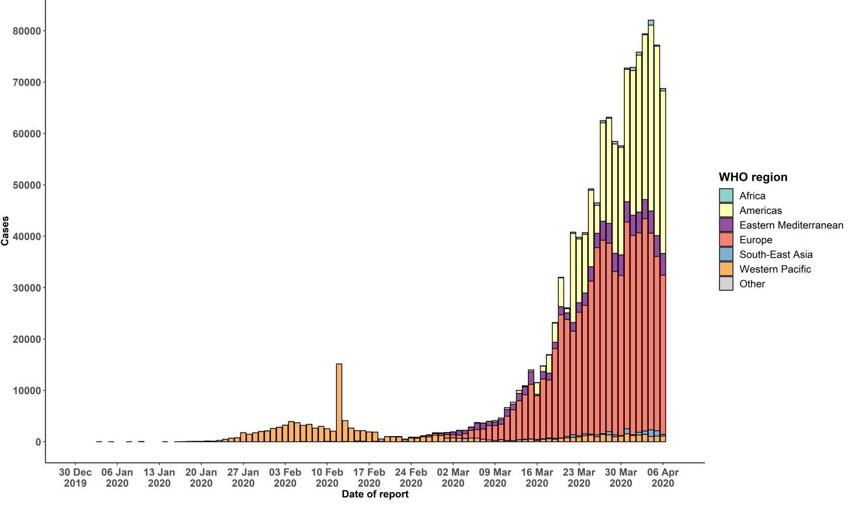

STRATEGIC OBJECTIVES

WHO’s strategic objectives for this response are to:

  - Interrupt human-to-human transmission including reducing secondary infections among close contacts and health care workers, preventing transmission amplification events, and preventing further international spread*;
  - Identify, isolate and care for patients early, including providing optimized care for infected patients;
  - Identify and reduce transmission from the animal source;
  - Address crucial unknowns regarding clinical severity, extent of transmission and infection, treatment options, and accelerate the development of diagnostics, therapeutics and vaccines;
  - Communicate critical risk and event information to all communities and counter misinformation;
  - Minimize social and economic impact through multisectoral partnerships.

*This can be achieved through a combination of public health measures, such as rapid identification, diagnosis and management of the cases, identification and follow up of the contacts, infection prevention and control in health care settings, implementation of health measures for travelers, awareness-raising in the population and risk communication.
PREPAREDNESS AND RESPONSE
- To view all technical guidance documents regarding COVID-19, please go to this webpage.
- WHO has developed interim guidance for laboratory diagnosis, advice on the use of masks during home care and in health care settings in the context of the novel coronavirus (2019-nCoV) outbreak, clinical management, infection prevention and control in health care settings, home care for patients with suspected novel coronavirus, risk communication and community engagement and Global Surveillance for human infection with novel coronavirus (2019-nCoV).
- WHO is working closely with International Air Transport Association (IATA) and have jointly developed a guidance document to provide advice to cabin crew and airport workers, based on country queries. The guidance can be found on the IATA webpage.
- WHO has been in regular and direct contact with Member States where cases have been reported. WHO is also informing other countries about the situation and providing support as requested.
- WHO is working with its networks of researchers and other experts to coordinate global work on surveillance, epidemiology, mathematical modelling, diagnostics and virology, clinical care and treatment, infection prevention and control, and risk communication. WHO has issued interim guidance for countries, which are updated regularly.
- WHO has prepared a disease commodity package that includes an essential list of biomedical equipment, medicines and supplies necessary to care for patients with 2019-nCoV.
- WHO has provided recommendations to reduce risk of transmission from animals to humans.
- WHO has published an updated advice for international traffic in relation to the outbreak of the novel coronavirus 2019-nCoV.
- WHO has activated the R&D blueprint to accelerate diagnostics, vaccines, and therapeutics.
- OpenWHO is an interactive, web-based, knowledge-transfer platform offering online courses to improve the response to health emergencies. COVID-19 courses can be found here and courses in additional national languages here. Specifically, WHO has developed online courses on the following topics:
  - A general introduction to emerging respiratory viruses, including novel coronaviruses (available in Arabic, Chinese, English, French, Russian, Spanish, Hindi, Indian Sign Language, Persian, Portuguese, Serbian and Turkish);
  - Clinical care for Severe Acute Respiratory Infections (available in English, French, Russian, Indonesian and Vietnamese);
  - Health and safety briefing for respiratory diseases - ePROTECT (available in Chinese, English, French, Russian, Spanish, Indonesian and Portuguese);
  - Infection Prevention and Control for Novel Coronavirus (COVID-19) (available in Chinese, English, French,
Russian, Spanish, Indonesian, Italian, Japanese, Portuguese and Serbian); and
  - COVID-19 Operational Planning Guidelines and COVID-19 Partners Platform to support country preparedness and response (available in English and coming soon in additional languages).
- WHO is providing guidance on early investigations, which are critical in an outbreak of a new virus. The data collected from the protocols can be used to refine recommendations for surveillance and case definitions, to characterize the key epidemiological transmission features of COVID-19, help understand spread, severity, spectrum of disease, impact on the community and to inform operational models for implementation of countermeasures such as case isolation, contact tracing and isolation. Several protocols are available here. One such protocol is for the investigation of early COVID-19 cases and contacts (the “First Few X (FFX) Cases and contact investigation protocol for 2019-novel coronavirus (2019-nCoV) infection”). The protocol is designed to gain an early understanding of the key clinical, epidemiological and virological characteristics of the first cases of COVID-19 infection detected in any individual country, to inform the development and updating of public health guidance to manage cases and reduce the potential spread and impact of infection.
RECOMMENDATIONS AND ADVICE FOR THE PUBLIC

If you are not in an area where COVID-19 is spreading or have not travelled from an area where COVID-19 is spreading or have not been in contact with an infected patient, your risk of infection is low. It is understandable that you may feel anxious about the outbreak. Get the facts from reliable sources to help you accurately determine your risks so that you can take reasonable precautions (see Frequently Asked Questions). Seek guidance from WHO, your healthcare provider, your national public health authority or your employer for accurate information on COVID-19 and whether COVID-19 is circulating where you live. It is important to be informed of the situation and take appropriate measures to protect yourself and your family (see Protection measures for everyone).

If you are in an area where there are cases of COVID-19 you need to take the risk of infection seriously. Follow the advice of WHO and guidance issued by national and local health authorities. For most people, COVID-19 infection will cause mild illness however, it can make some people very ill and, in some people, it can be fatal. Older people, and those with pre-existing medical conditions (such as cardiovascular disease, chronic respiratory disease or diabetes) are at risk for severe disease (See Protection measures for persons who are in or have recently visited (past 14 days) areas where COVID -19 is spreading).

CASE DEFINITIONS

WHO periodically updates the Global Surveillance for human infection with coronavirus disease (COVID -19) document which includes case definitions.

For easy reference, case definitions are included below.

Suspect case
- A patient with acute respiratory illness (fever and at least one sign/symptom of respiratory disease, e.g., cough, shortness of breath), AND a history of travel to or residence in a location reporting community transmission of COVID-19 disease during the 14 days prior to symptom onset.
OR
- A patient with any acute respiratory illness AND having been in contact with a confirmed or probable COVID -19 case (see definition of contact) in the last 14 days prior to symptom onset;
OR
- A patient with severe acute respiratory illness (fever and at least one sign/symptom of respiratory disease, e.g., cough, shortness of breath; AND requiring hospitalization) AND in the absence of an alternative diagnosis that fully explains the clinical presentation.

Probable case
- A suspect case for whom testing for the COVID-19 virus is inconclusive.
  - Inconclusive being the result of the test reported by the laboratory.
OR
- A suspect case for whom testing could not be performed for any reason.

Confirmed case
A person with laboratory confirmation of COVID-19 infection, irrespective of clinical signs and symptoms.
- Technical guidance for laboratory testing can be found here.

Definition of contact
A contact is a person who experienced any one of the following exposures during the 2 days before and the 14 days
after the onset of symptoms of a probable or confirmed case:
- Face-to-face contact with a probable or confirmed case within 1 meter and for more than 15 minutes;
- Direct physical contact with a probable or confirmed case;
- Direct care for a patient with probable or confirmed COVID-19 disease without using proper personal protective equipment1; OR
- Other situations as indicated by local risk assessments.

Note: for confirmed asymptomatic cases, the period of contact is measured as the 2 days before through the 14 days
after the date on which the sample was taken which led to confirmation.

1 World Health Organization. Infection prevention and control duringhealth care when COVID-19 is suspected
https ://www.who.int/publications-deta il/infection-prevention-and-control-during-health-care-when-novel-coronavirus-(ncov)- i nfecti on-is-suspected-20200125

